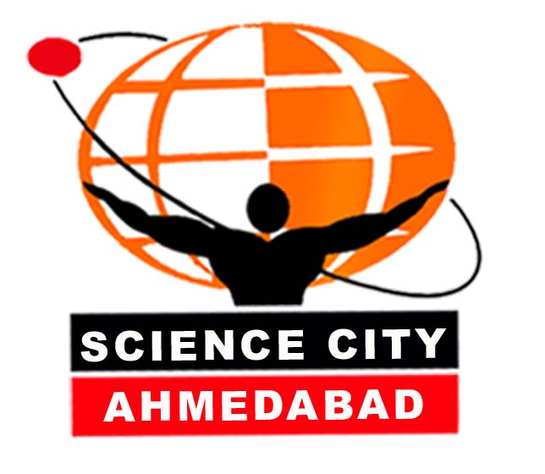
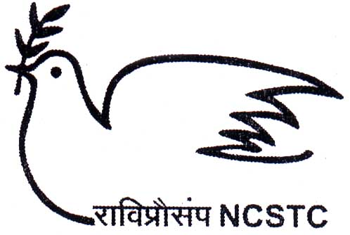
WORKSHOP ON
POPULAR SCIENCE WRITING & ILLUSTRATION
FOR SCHOOL CHILDREN
AT GUJARAT SCIENCE CITY

Gujarat Science City is organizing a series of popular science writing and illustration workshop for secondary school children of the state to inculcate scientific temper and attitude development among young students. The programme has been catalyzed and supported by the National Council of Science & Technology Communication (NCSTC), Department of Science & Technology, Government of India. It would be a pilot programme and the result will show more inspiration for the participants as well as the organizers.

The programme has been planned as an innovative activity on creative and popular science writing and illustration by the secondary school children (Class VIII and IX) through a series of workshops. The programme aims to inculcate scientific temperament and attitude among the young minds by understanding the science and technology better and to adopt the popular science writing, illustrations and reporting for further dissemination purposes.

Catch Them Young!

This will help the school students by understanding the concepts and methodology of science and allow them for their own creative interpretations in forms of popular science writings, illustrations. This is a very innovative way of developing children science literature and there is very little work has been carried out at any state and national level.

The programme has been planned for six workshops to be completed in one year duration. There will be five workshops, targeted to 50 selected participants from five districts of Gujarat at a time. The sixth workshop will be conducted as an advance level workshop for the 50 selected participants of the previous camps. Each of the workshops will be of four days duration.

The programme will train the participants about different science, technology and societal issues, how S&T could be harnessed to solve the different complex problems in the society. It also aims to train the participants on the basic skills in writing scientific stories, features, articles and scripts for different media like the print media as well as the sophisticated electronic media. Attempt will also be made for the participants that how they can able to fill their writings with appropriate illustrations and designs. The workshop is also intended to give a first hand knowledge about science journalism and will train the budding science writers to be professional science communicators and journalists in their future career.

Objectives of the programme:

- To inculcate scientific temperament and attitude among the young minds by providing the concept of popular science writing, illustrations and reporting.

- To help the students by understanding the concepts and methodology of science and to allow them for their own interpretations in forms of popular science writings, illustration

- To train the young students with the facility to have the professional skill in science writing, illustrations and journalism for development, communication and popularisation of science and technology ideas.

- To meet the needs of the mass communication industry by offering training in science writing and journalism, and to provide training to students who desire to pursue careers in newspapers, radio/television, advertising, public relations and other allied fields.

- To prepare science features and scripts (software) for local newspapers and other medias on topics related to science, technology and societal issues.

- To create a trend of amateur science writers and journalists well versed with the professional skill and experience who will mobilise the science popularisation programmes of the organisation and help us in the science literacy programme.

Target Group:

- Secondary School students from Std. VIII and IX from different districts of Gujarat, preference should be given to the rural and tribal area school students.
- Student members of various Science Club / VIPNET Club / Nature Clubs functioning as out-school campus in the state.
- Primary and secondary schools science teachers especially in tribal and rural areas.
- Young journalists of regional newspapers, local TV and Radio stations.

Resource Faculty:

The workshop will be conducted by eminent scientists and science communicators of the country as well as well known illustrator and creative experts. Dr. Manoj Kumar Patariya, Scientist ‘F’, Editor & Director at National Council for Science & Technology Communication (NCSTC), Department of Science & Technology, Govt of India, Dr. Tariq Baddar, Scientist & Science Communicator (CSIR), Dr. P. K. Shrivastav, Scientist, Central Drug Research Institute, Lucknow, Prof. Abid Surti, prominent illustrator, Mumbai, Prof.. S. K. Tiwari, Dean & Head Journalism, MS University, Vadodara, Prof. A. R. Prasanna, Sr. Professor, Physical Research Laboratory, Ahmedabad, Dr. V. P. Singh, Scientist & Editor, Indian Science Communication Society, Dr. Narottam Sahoo, Sr. Scientist, Gujarat Science City, Shri R. K. Sahaya, Scientist & Editor, Shri Manas Ranjan Mahapatra, Editor, National Centre for Children Literature (NBT) as well as many experience Science Writers and reporters.

Duration of the programme::

The programme has been planned for six workshops to be completed in one year duration. Each of the workshops will be targeted to 50 selected participants from five districts of Gujarat. By five such workshops, the programme will cover the entire 25 districts of the State. The sixth workshop will be conducted as an advance level workshop for the 50 selected participants of the previous camps.

Each of the workshops will be of four days duration. The first workshop in this regard was organised during 12th to 15th July 2007 for the participants of Ahmedabad, Gandhinagar, Kheda, Dahod and Panchmahal district. About 50 participants comprising of school students, VIPNET Science Club and teachers and budding journalists attended the workshop.

The second workshop has been scheduled during 23rd to 26th October 2007 for the participants from Valsad, Dang, Surat, Navsari and Narmada districts.

Learning to write is learning to think. . Let the young mind blossom… full of thought… the thought of prosperity!

We hope the workshop will nurture the young minds for exploration of science.

GUJARAT SCIENCE CITY
Capturing New Heights in Science Literacy!
WORKSHOP ON
POPULAR SCIENCE WRITING & ILLUSTRATION FOR SCHOOL CHILDREN

GUJARAT SCIENCE CITY
23rd to 26th October 2007

Programme Schedule

23rd October 2007 (Tuesday)

09:30 -10:30 hrs : Reporting at Science City Children Activity Centre
Breakfast & Registration Auditorium II, Food Court
10:30 – 11:30 hrs : Assembled in Auditorium I Dr. Narottam Sahoo
Why to read / write science? Sr. Scientist, GCSC
Expectation Analysis

12:00 – 13:30 hrs : Inaugural Function
Welcome Address Shri Ashok V. Mehta
Executive Director, GCSC
Floral Complements

Self Introduction by participants

Key-note address Mrs. Meenakshi Thakker
Technical Director, Doordarshan Kendra
Address by Guest of Honour Prof. R. K. Sahaya
Retd. Scientist/Editor, (CSIR), New Delhi
Inauguration by Chief Guest Shri Vagmin Buch
Director, Gujarat Energy Development
Agency (GEDA), Gandhinagar
Vote of Thanks Shri Pratik Shah
Project Manager, GCSC
13:30 – 14:30 hrs : LUNCH BREAK

14:30 – 15:30 hrs : Discussion on Popular Science Writing: Introduction and topics
Identification to each participant for developing scripts during the
Workshop

15:30 – 16:30 hrs : Lecture and discussion on techniques of popular science writing

Especially for print media (concept and scope of science writing)
Shri Japan Pathak, Sr. Journalist, Gujarat Samachar, Ahmedabad
16:30 - 16:45 hrs : Tea Break
16:45 – 17:30 hrs : Walk though in the Energy Education Park
17:30 – 18:00 hrs : Lecture and Discussion on various sources of scientific information
Writing of rough draft scripts by participants.
18: 00 – 19:00 hrs : Screening of Space Station MAX 3D Movie
19:00 – 20:00 hrs : Access to Digital Communication: Introduction of Internet and Email
Opening of email id for each of the participants
20:00 hrs : DINNER

24th October 2007 (Wednesday)

09:00 - 10:30 hrs : Discussion on draft article and Library reference
10.30 – 11.30 hrs : Lecture and discussion on various formats of science writing,
like fiction, skit, poem, etc.
(Prof. R. K. Sahaya, Scientist/Editor, New Delhi)
11:30 – 11:45 hrs : Tea Break
11:45 – 12:30 hrs : Writing Exercise continue
12:30 – 13:30 hrs. : Excitement in Space Science
Dr. P. S. Thakker, Sr. Scientist, Space Application Centre (ISRO)

13.30 – 14.30 hrs : LUNCH BREAK
14.30 – 15.30 hrs : Lecture and discussion on science writing for Radio / TV
Shri Maulin Munshi, Programme Executive, AIR, Ahmedabad
15.30 – 16.30 hrs : Experience in Motion Simulator with Tea Break
16.30 – 18.00 hrs : Interactive Session on Math magic
Making 3D Geometric Models using Modern Technology
Prof. Vijay S. Joshi, Associate Professor, Mathematics, (Retd.)
Virginia Intermont College, Bristol, V.A.
18:30 – 19:30 hrs : Library Session / Writing Exercise
Revision on rough draft scripts by participants.
19:30 – 20:00 hrs : Experience in Musical Fountain
20:00 hrs : Dinner followed by Sky Observation

25th October 2007 (Thursday)

09:00 – 10:30 hrs : Presentation of revised scripts in groups by the participants.
10:30 – 11:15 hrs : Lecture and discussion on science visuals / illustrations / cartoons /
Photographs, etc.
11:15 – 11:30 hrs : Tea Break
11:30 – 12:30 hrs : Science is Fun: Science Demonstration Auditorium II
12:30 – 13:00 hrs : Making Science Enjoyable: Children Science Magazines in
Gujarati/Hindi/English languages
13:00 – 14:00 hrs : LUNCH BREAK
14.30 – 16:30 hrs : Hands-on Experience in Print Journalism
Visit to Doordarshan Kendra, Ahmedabad
16.30 – 18.30 hrs : Interactive Session on Creativity & Innovation
An interactive session with Prof. Anil Gupta at IIM-Ahmedabad
19.00 – 20.00 hrs : Lecture and discussion on science writing as a career, including:
Press laws, ethics, awards, opportunities, etc.
20:00 hrs : Dinner

26th October 2007 (Friday)

09:00 – 10:30 hrs : Lecture and discussion on science editing / translation / terminology
10:30 – 11:00 hrs : Lecture and discussion on an overview of science journalism and
Science communication scenario in India.
11:00 – 11:15 hrs : TEA BREAK
11:15 – 12:30 hrs : Finalisation of scripts with the help of experts
12:30 – 13:30 hrs : Valedictory Function & Distribution of certificates
Chief Guest: Dr. Harsha A. Parikh, MD
Medical Director, Kesar Sal Medical College & Research Centre
13:30 – 14:00 hrs : LUNCH BREAK

15:00 – 17:00 hrs : Hymn to Agni: The God of Fire
Popular Science Lecture by Padmashree Prof. P. K. Kaw
Director, Institute of Plasma Research, Bhat, Gandhinagar

RESOURCE PERSONS

Dr. Manoj K. Patairiya
Director, National Council for Science & Technology Communication (NCSTC)
Dept of Science & Technology, Govt of India, Technology Bhavan, New Mehrauli Road, New Deilhi 110 016

Shri Tariq Baddar
Indian Science Writer’s Association
K. N. Nagar, Sector 19
Gaziabad

Dr. J. R. Trivedi
Senior Scientist
Physical Research Laboratory
Navarangapura
Ahmedabad 380 009

Dr. P. S. Thakkar
Senior Scientist
Space Application Centre (ISRO)
Satellite, Ahmedabad 380 015

Dr. A. R. Prasanna
Sr. Professor (Retd.)
Physical Research Laboratory
Navarangapura
Ahmedabad 380 009

Prof. Anil Gupta
Professor
Indian Institute of Management Ahmedabad

Dr. Saroj Ghose
Advisor, Gujarat Council of Science City
Sola-Santej Road
Ahmedabad 380 060

Shree Ashok Mehta
Executive Director
Gujarat Council of Science City
Sola-Santej Road
Ahmedabad 380 060

Shri A. R. Mahanty
Senior Manager
Gujarat Council of Science City
Sola-Santej Road
Ahmedabad 380 060

Shri Vagmin Buch
Director, Gujarat Energy Development Agency (GEDA)
Block No 11 & 12, 4th Floor
Udyog Bhavan, Sector 11
Gandhinagar 382 017
Dr. Vijay S. Joshi
Prof in Physics & Mathematics
3916, King Charles Road
Durham, NC 27707
919-768-6953
Email: joshijnd@gmail.com

Dr. Narottam Sahoo
Senior Scientist
Gujarat Council of Science City
Sola-Santej Road
Ahmedabad 380 060

Ms. Meenakshi Thakker
Technical Director
Doordarshan News
Doordarshan Kendra
Thaltej Ahmedabad
Tel / Fax: 26852073

Shri Japanbhai Pathak
Sr. Journalist
Gujarat Samachar
Khanpur, Ahmedabad 380 001
Tel: 3041 0000, Fax: 2550 2000

Shri Moulini Munsi
Sr. programme Executive
All India Radio
Income Tax Circle
Navarangapura
Ahmedabad

Dr. Harshaben Parikh
Medical Director
Keshar Sal Medical College &
Research Centre
Sola-Santej Road
Ahmedabad 380 060

Ms. Ragini Bharadwaj
Editor, NIE, The Times of India
Fadia Chambers, First Floor,
139, Ashram Road,
Ahmedabad 380 009
Tel: 2655 3300, Fax: 2658 3758

