GUJARAT SCIENCE CITY
presents
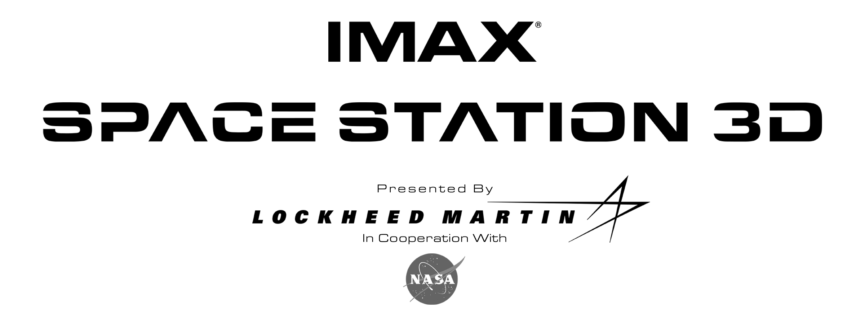

The exciting thing is that we don’t know what lies beyond the un-opened door…
and each door will open to many more doors… each answer leading to many more questions…
that is discovery.”
-NASA, “International Space Station Fact Book”

“Very few people can actually say they’ve been in space. But those who have been there—
astronauts and cosmonauts - have said that IMAX is the next best thing to being there.”
- Toni Myers, Producer, SPACE STATION 3D

The Space Station is a beautiful scientific film to be seen on our giant screen. A filed trip to Space Station whisks students 354 kilometers above the Earth to visit International Space Station, where our own Astronaut Sunita William spent a record time of six month for scientific exploration. Visitors will feel like they are working side by side with space exploration, orbiting the Earth every 90 minutes, traveling at 28,160 kilometers per hour.

As astoundingly beautiful as it is technically dazzling, SPACE STATION 3D is the first-ever IMAX 3D space film, the greatest engineering feat since landing a man on the Moon.

The film describes the story of unique partnership of 16 nations building a laboratory in outer space -- a permanent facility for the study of the effects of long-duration exposure to zero gravity and the necessary first step towards the global co-operative effort needed if man is to someday set foot on Mars. It is a story of challenges, setbacks and triumphs…and ultimately, the shared international victory of men and women whose dreams exceed the limits of life on this Earth.

The SPACE STATION in 3D format is the first cinematic journey to the International Space Station (ISS), where audiences can experience for themselves life in zero gravity aboard the new station. Transported by the magic of the IMAX 3D technology, the audience blasts off into space with the astronauts and cosmonauts from Florida's Kennedy Space Center and Russia's Baikonur Cosmodrome to rendezvous with their new home in orbit 220 miles above Earth. People of every age and language can work side by side with their space-walking crewmates, building and inhabiting this unprecedented structure in space.

Presented by Lockheed Martin Corporation in co-operation with NASA, and distributed by IMAX Corporation, the film is produced and directed by Toni Myers and narrated by Tom Cruise. James Neihouse is the Director of Photography and Astronaut Training. The music is by Micky Erbe and Maribeth Solomon.

Gujarat Science City, working under the aegis of Department of Science & Technology, Govt of Gujarat is emerging as a large scale science popularisation platform in the country. With its innovative activities and programmes, the Gujarat Science City is capturing new heights in Science Literacy!

MAKING OF SPACE STATION 3D

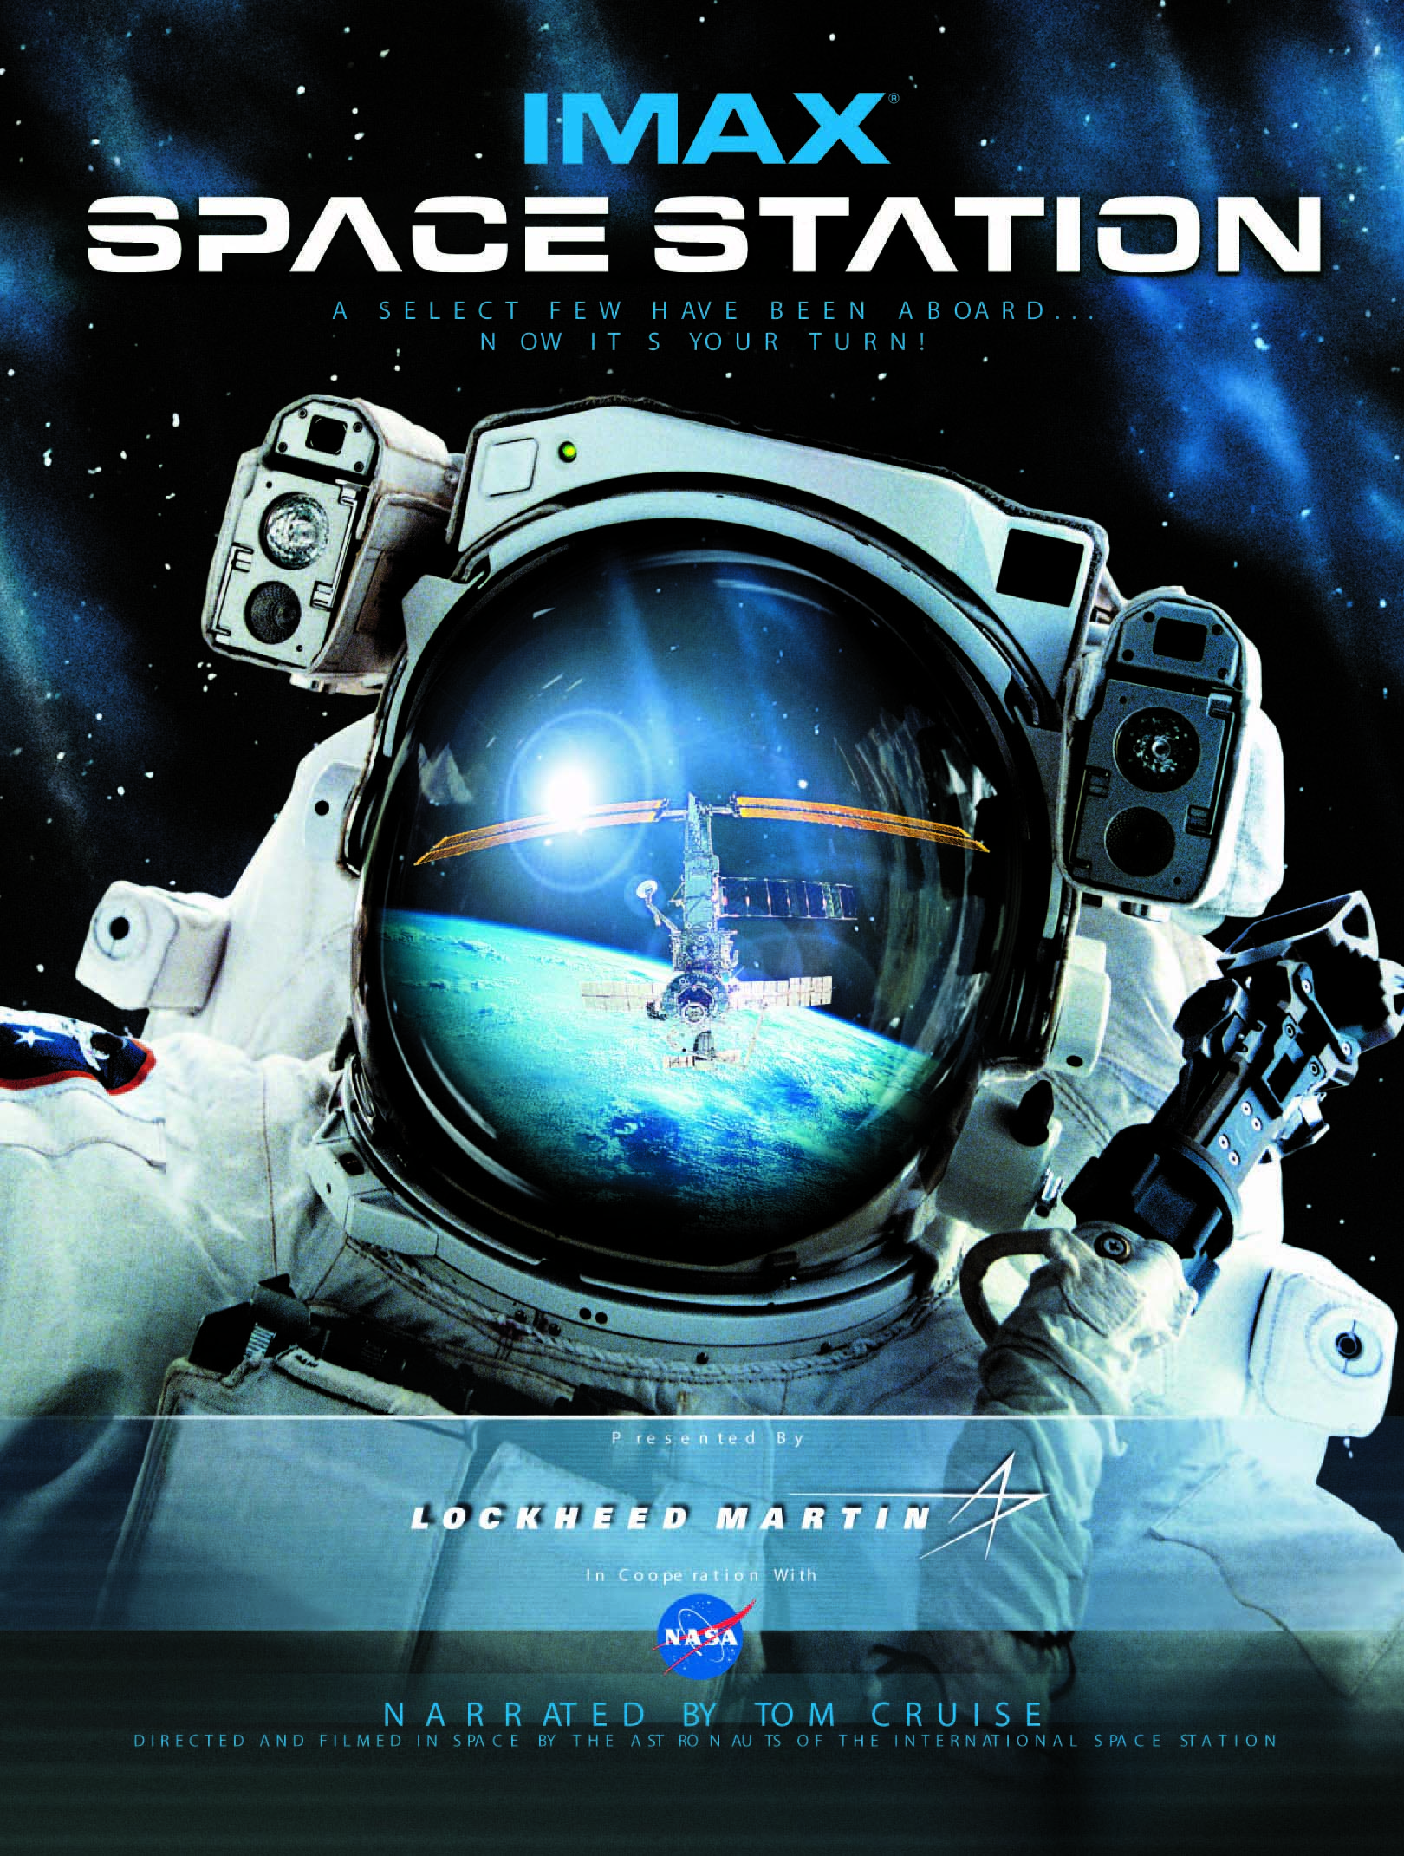
As the National Aeronautics and Space Administration (NASA) progressed with the first construction phase on the International Space Station, the organization realized the amazing opportunity it had to record the ground-breaking second phase--the on-orbit construction of the Station. Leaders within the Administration decided to solicit proposals from large-format filmmakers for the privilege of documenting the building of the ISS.

Given its sterling reputation within the field and its canon of superlative previous films on the subject of space (including The Dream Is Alive, Blue Planet, Destiny In Space and Mission To MIR), IMAX submitted its bid, along with several others filmmakers, in the open competition. Aided by its past experience and that fact that the images of the Space Station would be filmed using the company’s advanced 3D technology, IMAX was ultimately chosen by NASA to make SPACE STATION 3D. SPACE STATION 3D builds on the IMAX-Lockheed Martin-NASA heritage that began almost 20 years ago and has now produced five major large-format IMAX films such as The Dream Is Alive, Blue Planet, Destiny In Space and Mission To MIR that have been seen by 70 IMAX million moviegoers around the world.

There was little question with regard to the filmmaker best qualified to handle the project. A key member of the IMAX space team, Toni Myers had written and edited the space films The Dream Is Alive, Blue Planet and Destiny In Space and served as producer/writer/editor of L5: First City in Space and Mission To MIR. As she approached the new film, her enthusiasm seemed boundless.

Producer/Director Myers explains, “Well, it goes without saying, I’m a space enthusiast, having been involved in four space films. And this was no different. The opportunity to film a feat of engineering that’s absolutely unprecedented in history, to capture that on film and, especially, to employ a brand new technology that had never been used there before…those were really good reasons to want to do this film.”

Co-founder of IMAX Corporation Graeme Ferguson (and Consulting Producer on SPACE STATION 3D), discussing how IMAX’s previous space films have led to this newest project, explains, “Each of those dealt with a specific theme, as does this one. Toni’s first film on the subject, The Dream Is Alive, was an introduction, really, to life in low Earth orbit. Blue Planet was about Earth and what you can learn about observing it from the unique perspective of orbit. The third film, Destiny In Space, looked the other direction, to the exploration of other stars and planets beyond our own. Mission To MIR, the fourth film, which could really be considered a prequel to this film, documented the first time that Americans and Russians (who had been former Cold War enemies) had combined forces to attempt to work together in space. The successful completion of that mission prompted NASA to begin the planning stages of what eventually would become the International Space Station. Because of the IMAX 3D technology, SPACE STATION 3D is a complete leap in how you see and experience everything over the previous four films.”

Yet with the filmmakers’ enthusiasm came the realization of the immense amount of work that lay ahead of them. The IMAX 3D cameras, as they existed at the time, were too cumbersome to be considered for usage inside the ISS. From the start, NASA dictated that any camera intended for use in-orbit would have to fit inside a single mid-deck shuttle locker.

Myers elaborates, “The classic IMAX 3D cameras capture images on to two strips of film simultaneously--one for the left eye and one for the right eye. Those two strips of film are then projected on a two-strip projector to make the 3D imagery that you see. No matter how the filming is completed, we still have to project the finished film this way. But we had a real challenge when it came to how to shoot 3D in space.

“We knew we could never launch with the two-strip system. So we worked with some of the same IMAX technicians who have built many of the IMAX 2D cameras to crack this technical problem. We came up with a unique design where both strips of film, one for each eye, could be exposed on one strip, with the left- and right-eye images captured on adjacent frames on a single strip.”

Traditionally, motion picture film is exposed at 24 frames per second. One drawback to the newly created single-strip design, which eliminates the need for synchronizing two strips of film, is that the same amount of film results in half the length shot (since each frame is really two adjacent IMAX frames travelling through the camera simultaneously). With film being used at more than 11 feet a second, the new system, though ingenious, renders the film a costly and dear commodity.

Size constraints were not the only challenges facing the IMAX camera designers.

Myers continues, “When you’re compressing the size of the camera down into a very small area, as we did, that’s where the electronics come into play. We were nervous because a great deal of the electronics that would go into making this ingenious camera possible--such as computer chips--are very susceptible to the cosmic and solar radiation present when you’re on-orbit. It can just knock out a chip and can effect the camera, sometimes just intermittently, but enough to stop the camera in the middle of a shot. So we were very nervous about relying on chip technology. But we had no choice, given the size constraints.”

The filmmakers found their experience garnered while shooting previous space films invaluable. Because of their relationships cultivated within Lockheed Martin and NASA, they were able to call upon astronauts, mission specialists, scientists and engineers to advise them during the camera design stage. Various mock-ups were created and supplied to the astronauts, who had input on many aspects, from handle design to control knob placement. The filmmakers and camera designers, who themselves had never shot a film in space, relied heavily upon their panel of advisers and their experience shooting under zero-G conditions.

With the accelerated design schedule, the 3D space camera team were not afforded the luxury of a long test and de-bugging period. Luckily, they would eventually discover that the revolutionary cameras functioned beautifully under the rigorous conditions of space.

In addition to massive camera re-design work, hundreds of man hours would have to be devoted to training the astronauts and cosmonauts working on the Space Station, for they would serve as cameramen and cinematographers (as well as sound and lighting engineers) during filming. While shooting regular motion picture film under normal conditions would prove a challenging task for anyone, it would take special training for the astronaut filmmakers to avoid the pitfalls while judiciously exploiting all of the possibilities inherent in 3D filming--all the while shooting 220 miles above the Earth!

“We’ve advanced from the crude sort of trickery used in the first 3D films of the 1950s, which we call ‘the spear in the eye,’ or constantly having something project from the screen to remind the viewers that they were experiencing 3D. We’ve developed a more sophisticated camera language to maximize the 3D effect, and that includes almost constant camera movement. That’s a very effective way to keep the 3D cues going in the viewer’s brain. Camera operators and cinematographers also have to be cautious of space between the lenses, as well as the distance from the subject to the lens. All of this effects the quality of the final 3D images, and we had to train the astronauts and cosmonauts to be conscious of all of these aspects,” says Myers.

No mean feat, indeed, given the rigorous amounts of training those working on the ISS would undergo for the myriad of takes associated with functioning and troubleshooting in space while constructing the Station. Not only would these men and women be creating the massive orbiting research and living facility, but documenting their work on the taxing medium of 3D large-format film.

Once NASA supplied Myers and her team with the list of flights where filming was to take place, the filmmakers held familiarization sessions with the flights’ crews and introduced them to IMAX filming techniques by screening some of the company’s previous films. Also, a talk was given on rudimentary 3D filming techniques (and how it differs from shooting traditional 2D) and the filmmakers-in-training began to become familiar with the hardware (the camera, the lighting and sound equipment) that would be involved in the shooting of SPACE STATION 3D. (Myers remembers that the first familiarization session was held so early that the 3D space camera had yet to be completed.)

Following the introductory sessions, the Commanders then singled out two or three crew members from each flight and assigned them specific filmmaking tasks; those crew members continued on with specialized training in their assigned areas. At that point, James Neihouse (Director of Photography and Astronaut Training) began basic technical training, which included how to load and unload the magazines that contained the 108 seconds of 65mm film negative. (This particular task involves advanced dexterity, as the magazines must be handled inside of a black bag to avoid possible exposure to light; the mission cameramen practiced the maneuver repeatedly until they achieved proficiency.)

From there, more advanced techniques, such as lighting and scene composition, were taught. Myers also discussed the basics of overall film editing, encouraging her space-bound auteurs not to shoot shorter “throw-away” scenes. Separate sessions were held to teach sound recording techniques. Once all of “3D Filmmaking 101” was covered, the hands-on lab hours began.

Myers explains, “Once they had reached that point, we gave the mission crews equipment and a roll of film and we took them to the mock-up of the Space Station at Johnson Space Center for a shot at practical filmmaking. They set up their own lights; they aligned the scene inside; they designed the scenes they were going to shoot; and they directed the subjects in their scenes. Once they completed three scenes, we processed the film and then showed it to them and their colleagues on the giant screen for critique. That was really the turning point in their film training. The writing is on the wall by then. If they haven’t yet quite mastered things such as depth of field, good lighting and sharp focus, they sure learned it then…because nothing speaks louder than a scene that’s ill-lit or in soft focus.”

The entire film course averaged about 22 hours spread over the months which preceded each crew’s mission. This filmic training continued up until the astronauts entered quarantine, which was one week prior to launch. Last-minute sessions were held to practice magazine loading and unloading, and all the while Myers worked with crews to develop and hone a list of scenes she had hoped would be shot.

These master scene lists were the product of true co-operation between the producer/director and the crew members.

Myers elaborates, “I took a lot of input from them because they knew better than anyone what might be interesting to shoot on any given flight. So we worked together to develop the shopping list of scenes and they’d tell us what might look good and what would be interesting, and also if we were asking for things that they couldn’t possibly shoot. So we developed the list right up until the last minute.”

Scheduling sometimes proved challenging, but the crews took their filming assignments seriously and fully committed to the tasks at hand. The Expedition-1 crew (Commander Bill Shepherd with Russian Cosmonauts Yuri Gidzenko and Sergei Krikalev) completed their IMAX training nearly two years before their scheduled flight. While proficient at the time, their practical skills grew rusty. Anxious that they were not as fluent as they should be, the crew hoped to find more training time as their scheduled mission drew near. The ground filmmakers, who were travelling to Russia in order to cover the launch, co-ordinated their schedules with the Expedition-1 crew and held refresher courses in a Moscow hotel. Eager to practice up until the last minute, the crew even worked with Myers at Baikonur (800 miles Southeast of Moscow) while under pre-flight quarantine--with Myers and her colleagues wearing surgical masks as they watched Shepherd, Krikalev and Gidzenko loading and unloading film magazines.

(On a side note, Myers comments that shooting in Russia came with its bag of challenges. She remembers, “While in Kazakhstan to film the launch of the first station components, we had to sort of operate in a ‘guerrilla mode.’ When you’re in a place like Kazakhstan, you have to imagine everything you’re ever going to need, because it’s an absolute certainty that you won’t be able to buy it on location. And so we took everything we could conceivably use with us. And that included fifteen-hundred meters of telephone wire in case we were allowed to do a hardwire start for our cameras. Then you have to get all of your equipment through customs. That’s when you truly feel like a S.W.A.T. member.”)

Myers was duly impressed with the tenacity and acumen of her orbiting filmmakers.

She observes, “The crews actually worked very, very hard when they were filming on-orbit for us. We had to accomplish 90% of our filming in the few days when the shuttle was docked to the Station. And that, of course, was the peak busiest time for both the visiting shuttle crew and the resident crew. They were unloading all kinds of experiments, supplies, food and clothing--it was a non-stop, heavy-duty move and they worked extremely long days. It’s miraculous that they got the scenes that they did. I mean, in the middle of all of this activity, the crew members assigned to film would have to get the scene set and lit and then move around the station, rounding up the people who were the subjects and then rehearse the scene…all of this under extreme pressure to remain within their mandated schedule. Talk about the pressures of filmmaking!”

Other developments proved challenging once filming began aboard the ISS. Myers and her colleagues had been told that if left on board the Station for more than 16 days, the 65mm film negative would become fogged by the same cosmic and solar radiation that can sometimes effect computer chips. It was deemed too high a risk to allow this already invaluable footage to become useless as a result. So film delivery and pick-up had to be co-ordinated with the shuttle flights (which remained docked at the Station for approximately 10-12 days). This left precious little time for error and compounded the already busy schedule of the crews during those peak periods. Filming, though important, came after an extensive list of Station inhabitants’ duties.

Even booking the exchange of film magazines was, at times, difficult. As the station began to evolve, certain pieces of equipment (such as the Russian air-conditioner) required service or replacement. All cargo space aboard the shuttle was at a premium, and sometimes last-minute and vital shipments would take up the space allotted for IMAX film. During one particular period where Station function and filming activity were at a simultaneous high, the shipping of film became catch-as-catch-can. But thanks to the supportive team at Johnson Space Center, the film delivery channel remained open.

For whatever setbacks there were, though, there also came triumphs:

- A brand new 3D technology, which had not even been tried on the ground, is sent up into space and works perfectly. The IMAX 3D Cargo Bay camera (ICBC3D) vividly captures the formidable nature of constructing a complicated free-floating structure in the vacuum of space.

- As an experiment, 65mm film negative is left on board the Station for longer than the prescribed 16 days and does not exhibit any signs of solar or cosmic radiation fogging. As a result, film for use in the IMAX3D space camera can be stored in the Station for crews to shoot at their leisure (providing some of the most satisfying footage--including scenes of the Expedition-2 crew on-orbit--brought back to Earth).

- Although positive about the results of shooting SPACE STATION 3D in 3D, experienced filmmakers know that the product doesn’t always match up with the intention. Shooting 3D scenes while under Earth’s gravity, mocked-up to approximate the final scenes shot in zero-G, could really only provide an educated guess. As the footage comes back to Earth and is processed into 3D imagery, Myers and her colleagues at IMAX are blown away by the spectacular view of life 220 miles above the Earth’s surface. The combination of the technology and the talented orbiting filmmakers is evident in the thrilling footage.

- Taking Myers’ basic 3D filming techniques to heart, the astronauts and cosmonauts do everything possible to keep the camera moving by employing several techniques including one coined “human dollying,” where the crew member operating the camera would be pulled or pushed by another crew member…a human dolly effect. Cosmonaut Sergei Krikalev of the Expedition-1 crew, who had previously spent a year in space prior to his Space Station stay, proves a master at moving around in zero-G. (Myers says watching Sergei is like “watching a ballet dancer--he’s absolute perfection in that medium.”)

- The flying acumen, skill and focus of the shuttle pilots and Commanders combine in the execution of technically challenging “fly-around” shots. The shuttle maneuvers in a circle four- to six-hundred feet around the Station. The placement of the Station, beautifully lit with the Earth providing a backdrop--these shots required split-second timing on everyone’s part to calculate the trajectory of the shuttle in relation to the placement of the Sun, the Station, the Earth. With no chance for error, the shots would either happen or they wouldn’t. Filmmakers received not one but two of these breathtaking shots from their orbiting colleagues.

- All through the NASA system, it takes hundreds of people to support a flight--any flight of the shuttle--and an entirely different set of people who support the actual operations on the Station. Teamwork from everyone involved resulted in the success of the filming of SPACE STATION 3D.

When the final footage shot in the Station returned to Earth, the challenges were far from being over for Myers and her IMAX team. The single strip of adjacent left- and right-eye images must be separated back into two strips--a laborious and difficult process for the technicians at the IMAX film lab--for the final IMAX 3D projection technique to be successful. The resulting film effect dazzles even Myers, who’s been working with three-dimensional film technology for more than three decades; she is not surprised when, during early screenings of the scene of the Proton rocket launch, audience members take off their glasses to see if they’ve been damaged by the flying debris in the wake of the powerful rocket’s exhaust.

Myers says, “I would say the IMAX 3D technology is the fantastic thing about this film. I mean, it is fantastic to be able to travel into orbit in any way possible, but 3D absolutely puts you right there, aboard the Space Station, in a way that no other medium or technology can. It’s an experience unlike any other.”

The producer/director was also duly impressed by the Hollywood legend who, compelled by his enthusiasm for flight and space travel and himself impressed by an early screening of the footage, signed on to narrate SPACE STATION 3D.

“We’re just incredibly fortunate that Tom Cruise agreed to be our narrator. The story of SPACE STATION 3D is actually, as I had envisioned, told by the cosmonauts and astronauts who built the Station and lived there. And that is, in fact, true. But you need, when you make a film in this manner, to have another voice that ties it all together and puts everything in perspective for the viewer…and that’s what Tom Cruise does.

“Tom is extremely enthusiastic about space and is also a pilot. I know that he’s also a real IMAX enthusiast. When he brought his kids to see an early screening of the promotion reel, that really swayed him…it knocked his socks off. We are very honored to have him participate in this venture,” notes Myers.

When asked what she feels the International Space Station will contribute to humankind in the future, the maker of SPACE STATION 3D is extremely optimistic. She believes that during its relatively brief existence, the Station has already contributed a great deal; the very fact that people from many different countries around the world can work together to construct something on such a scale in space is already a huge achievement.

- Looking forward to returning to the Moon and perhaps building a base there or some kind of structure on Mars--that is a skill that we have already acquired.

- We now have never-before-obtainable data on what happens to the human body outside of the effects of Earth’s gravity and atmosphere.

- The Station continues to provide an environment of weightlessness unlike any other, where invaluable experiments can be conducted in molecular structure and design, cell growth and possible disease prevention.

- Exact benefits are hard to quantify at this point, because some of the greatest discoveries come from unforeseeable developments. Answers are sought only by searching in new environments, such as aboard the ISS.

While she believes that the benefits of International SPACE STATION 3D are far-reaching, with some perhaps not to be realized for some time, Toni Myers will remember and hold a small moment-a quiet benefit-as perhaps her most personal impression of the ISS.

“What was my most memorable experience while filming SPACE STATION 3D? One that sticks out right away: it was on STS-97 that was the flight on which our first interior rolls of footage were set to be shot. Days had gone by and we had yet to hear a word. It was getting close to the end of the flight and we were a little worried about their progress and whether they were actually going to get anything done at all.

“Anyway, we were at Mission Control, and we were very relieved to see in the monitors that they had begun shooting--and this happened right as the Station was set to pass over Houston at night. This was all over the news, that the Station was going to be the brightest star in the sky that night…but I had never seen it. I remember going downstairs at Mission Control--having just seen our camera and everybody gathered around it setting up for a shot--and out into the parking lot outside and looking up and seeing the Space Station sailing across the night sky…from one side, one-hundred-and-eighty degrees, over to the other, and just thinking of the fact that, up there, they were running the camera and filming our scenes. It just gave me shivers,” closes Myers.

IMAX Corporation and Lockheed Martin Corporation present, in co-operation with the National Aeronautics and Space Administration, SPACE STATION 3D. The film is narrated by Tom Cruise. The Director of Photography and Astronaut Training is James Neihouse. The music is by Micky Erbe and Maribeth Solomon. The Associate Producer is Judy Carroll and the Consulting Producer is Graeme Ferguson. SPACE STATION 3D is Produced and Directed by Toni Myers. The film is distributed by IMAX Film Distribution and is available for giant-screen IMAX theatres worldwide.

ABOUT THE SPACE CAMERAS AND IMAX

Between December 1998 and August 2001, more than 69,000 feet (that’s 13 miles) of 65mm film negative was flown into space for use in the two different IMAX® 3D space cameras designed specifically for use on the Space Station. These cameras were designed and built over a period of two-and-one-half years by MSM Design Inc. under the supervision of, and for, IMAX Corporation. The two cameras are known as the IMAX 3D Cargo Bay camera (ICBC3D) and the IMAX 3D camera (IMAX3D).

The ICBC3D system was hard mounted in the space shuttle cargo bay in its own environmentally sealed container to capture bird’s eye views of spacewalks and Station assembly. The camera is remotely controlled by a laptop computer from inside the Station; this allows the 25 astronaut and cosmonaut filmmakers to frame their shots, select focus and exposures and choose from alternate camera lenses. The ICBC3D holds about eight minutes worth of film (5,400 feet) and could not be reloaded with new film during flight; the camera travelled up and down on the various shuttle missions and was reloaded after the shuttles returned to Earth.

The IMAX 3D camera was specifically designed for filming within the ISS, moving from module to module to capture scenes of daily life on the inside. This camera is loaded with one 1220-ft. film roll that provides 108 seconds of filming time--which was removed after shooting and reloaded with new film by the in-orbit filmmakers. The IMAX 3D remained on the Space Station for 337 days.

“IMAX Corporation is at the leading edge of technology and we are continuously finding ways to bring unique experiences to audiences around the world,” says IMAX Corporation Co-CEOs Richard L. Gelfond and Bradley J. Wechsler. “These new cameras are a perfect example of this ingenuity. Only IMAX 3D technology can transport audiences to such extraordinary places, like the Space Station. When projected on to our six-story screens with 12,000 watts of surround-sound, these 3D images literally launch audiences into space to witness history in the making.”

The primary difference between a traditional IMAX 3D camera and the space 3D camera is the technique of recording the 3D information. The traditional IMAX 3D camera records the left- and right-eye images on two separate strips of film, while the 3D space camera records the left- and right-eye images side by side on a single strip of film. This allows for a more compact camera design. (The customary two-strip 3D cameras are approximately the size of a safe and require four men to maneuver. With the breakthrough of the single-strip 3D technology, a considerably smaller camera could be designed--the IMAX 3D, without the video display and mounted handgrips, measures approximately 10” by 17” by 30”. Because the ICBC3D was required to hold a greater amount of film between reloads, its finished size is a little smaller than a bar refrigerator.)

During development, the left- and right-eye images are separated back into two strips for the projected three-dimensional effect.

The technical breakthroughs in creating the IMAX 3D space cameras were the first steps necessary in achieving the goal of filming IMAX 3D in space and are part of a continuing commitment by IMAX Corporation to remain the leader in 3D film technology.

Recognition should also be given to Lockheed Martin and NASA for designing and building the ICBC3D container, providing the engineering support necessary to get the IMAX cameras certified for space, processing the camera hardware for flight and providing mission support for the IMAX filming activities. Most of all though, it is the astronauts who worked so hard with the IMAX cameras, under very demanding circumstances, to bring the experience of space back to Earth on film.

IMAX Corporation is the pioneer and leader of giant-screen large-format film and motion simulator entertainment. It is the leading provider of high-impact out-of-home high technology entertainment systems.

IMAX technology combines a variety of technological innovations: special cameras, special projectors, wide screens, specially-designed theatres with steeply raked seating and films shot on 65mm negative stock.

IMAX technology uses the largest commercial film format in motion picture history (70mm, 15-perforation), three times the size of regular 70mm and 10 times the size of conventional 35mm films projected in a normal movie theatre.

IMAX films are projected on giant screens (up to eight stories high), which extend beyond the moviegoer’s peripheral vision--so big, in fact, that a whale can appear life-size--giving the moviegoer the sense of being right in the action.

The projectors utilized are some of the most advanced ever built and use IMAX’s proprietary Rolling Loop technology. Each frame is positioned on fixed registration pins; the film is held firmly against the rear element of the lens by a vacuum. A 68 percent shutter transmits one-third more light than a conventional 50 per-cent shutter. In 1997, IMAX Corporation was awarded an Oscar®, the Academy of Motion Picture Arts and Sciences’ highest honor, for scientific and technical achievement.

IMAX theatres feature a patented digital audio technology with advanced circuits designed specifically to enhance sound clarity and depth of sound reproduction. IMAX sound also uses proprietary signal processing, amplification and loudspeaker design.

IMAX films are shown in specially-designed theatres where the seating decks are steeply raked, so that even a child’s view is unobstructed and people can look up and down, as in real life.

IMAX 3D technology is acknowledged to be the best 3D in the world. IMAX has both a special 3D camera which incorporates two camera movements into one housing for use on land and an advanced 3D camera for filming in space. IMAX 3D presentations can be viewed using either IMAX 3D glasses with polarizing filters or electronic liquid-crystal shutter glasses.

With the IMAX 3D effect using polarized glasses, the images are projected onto a huge, flat screen via two polarized lenses that focus the separate left- and right-eye images of the two separate strips of film onto the screen. The audience wears polarized glasses which have the same polarizer alignment in each lens as the projector and this allows excellent alignment and picture steadiness.

Used to show left- and right-eye images of each scene, IMAX E3D (electronic liquid-crystal shutter) glasses sense an infra-red signal from the projection system. The shutters alternately open and close 48 times per second, allowing each eye to see the appropriate image. The theatre disappears as images float through the air, enveloping the viewer in the film.

SPACE STATION AT A GLANCE

Description: As astoundingly beautiful as it is technically dazzling, SPACE STATION 3D is the first-ever IMAX 3D space film. Audiences will travel 220 miles above Earth at 17,500 mph to experience SPACE STATION 3D—the greatest engineering feat since landing a man on the Moon. This film is presented by Lockheed Martin and in cooperation with NASA.

Format: 15/70, 3D

Director: Toni Myers and the Crews of the International Space Station

Producer: Toni Myers

Music By: Mickey Erbe and Maribeth Solomon

Starring: The Astronauts & Cosmonauts of the International Space Station

Narrator: Tom Cruise

Presenting Sponsor: Lockheed Martin

Distributed By: IMAX Corporation

Film Length: 47 minutes 06 seconds

Credits: See Production Notes

Release Date: April 19, 2002

Theatres: SPACE STATION is scheduled to open in over 90 IMAX theatres worldwide.

Fun Facts: Between December 1998 and July 2001, more than 69,000 feet, or 13 miles of 65mm film will have been flown into space for filming of SPACE STATION 3D.

The new IMAX 3D film, SPACE STATION 3D is being filmed at 17,500 miles per hour as the ISS orbits Earth. The Earth's surface is rotating about its axis at 1,532 feet per second at the equator, and the planet zips around the sun at more than 18 miles per second!

To shoot one minute in 3D takes twice as many feet of film as 2D. Fact: 336 feet of 70mm/15 perforated film is equal to one minute of screen time in 2D, but only 30 seconds when shot with the IMAX 3D space cameras.

SPACE STATION 3D FILMING FACTS:

• Between December 1998 and July 2001, more than 69,000 feet, or 13 miles of 65mm film will have been flown into space for filming of SPACE STATION 3D.

• The new IMAX 3D film, SPACE STATION 3D is being filmed at 17,500 miles per hour as the ISS orbits earth. The Earth's surface is rotating about its axis at 1,532 feet per second at the equator, and the planet zips around the sun at more than 18 miles per second!

• When completed in 2006, International Space Station had a wingspan of 365 ft, and a length of 262 ft. If all the film shot the for the new IMAX film SPACE STATION 3D were placed end to end on the wingspan, it would go back and forth over nearly 189 times!

• To shoot one minute in 3D takes twice as many feet of film as 2D. Fact: 336 feet of 70mm/15 perforated film is equal to one minute of screen time in 2D, but only 30 seconds when shot with the IMAX 3D space cameras.

IMAX 3D CAMERA FACTS:

• Two 3D cameras went to space for the making of SPACE STATION 3D:

- The In-Cabin Camera (interior camera, called IMAX3D) remained on Space Station for 337 days between September 13, 2000 and August 16, 2001.

- The Cargo Bay camera (exterior camera, called ICBC3D) was bolted into position within the cargo bay of the Space Shuttle, and traveled up & down on seven shuttle missions.

- The IMAX®3D Cargo Bay camera holds 5400 ft (or 1645 meters) of film, which is longer than one mile (or 1.6 kilometers).

• The light from an IMAX projector, if pointed up towards space from Earth, could be seen with the naked eye from the Space Station.

INTERNATIONAL SPACE STATION FACTS:

• With the participation of 16 countries, the International Space Station is the first truly international space project.

• “Zarya,” which means “Dawn” in Russian, is the name of the first component of the ISS – the Russian Functional Cargo Block.

• “Unity” is the name of the U.S. Node and was the second component of the ISS.

• “Canadarm 2” is the name of the Canadian-built giant robotic arm that can “walk” around the Space Station.
• “Destiny” is the name of the U.S. lab module.

• “Raffaello” is the name of the Italian-built multi-purpose logistics module that contains scientific equipment racks for the U.S. lab, “Destiny.”

ASTRONAUT FACTS:

• 25 astronauts were trained to use the IMAX 3D cameras for this film.

• Astronauts are trained for jobs outside their special skill set. As part of their cross-training some astronauts were trained for both cameras, some for only one; some were trained for interior camera lighting, some were trained for sound and some were trained on all IMAX equipment.

• To achieve necessary film angles in the first-ever IMAX®3D space film SPACE STATION 3D, astronauts acted as human dollies.

IMAX FACTS:

• More than 70 million people world-wide visit an IMAX theatre every year.

• With screens over eight stories high and 15,000 watts of surround sound, the IMAX experience is the most powerful and involving film experience.

• IMAX film uses the largest film frame in the motion picture industry. It is 10 times the picture area of conventional 35 mm film frame.

