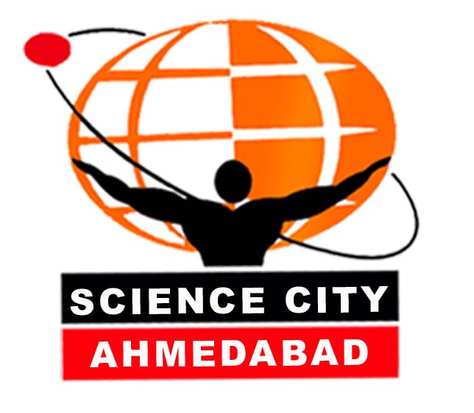

CELEBRATION OF WORLD POPULATION DAY
Wednesday: 11th July 2007

Gujarat Council of Science City (GCSC), working under the aegis of Department of Science & Technology, Government of Gujarat, has been emerging as a large scale science popularization platform in the country. GCSC has taken the responsibility of designing innovative activities and programmes in emerging areas of science and technology and implementing the same for the noble cause of science dissemination and popularization. With its multi-disciplinary programmes and participant-oriented approach, the Gujarat Science City is capturing new heights in science literacy.

The scientific and educational activities in the Science City has been organized as (i) science popularization programmes: (i) celebrating science, (ii) academic programmes on science and math, (iii) material development, (iv) training volunteers, (v), media resource centre, and (vi) coordination of science clubs etc.

The broad objective of these programs is to create and sustain a culture of learning that fosters the process of personal inquisitive, experimentation, communication, documentation, understanding, and the sharing of values on science and society.

The programme provides an opportunity for students to become immerse in the adventure of science learning by spending an extended period at Science City. The creative, enthusiastic and entrepreneurial approach of each of the activitities makes it effective and relevant, meeting the secondary and higher secondary curriculum.

Celebration of World Population Day:

Gujarat Science City has been planned to organize various activities on the theme ‘Men as Partners in Maternal Health’ on Wednesday, the 11th July 2007 to mark the celebration of World Population Day.

As a part of this celebration, a seminar on ‘Men At Work’ has been arranged from 10.30 hrs to 17.00 hrs. The seminar will discuss how men play a key role in bringing about gender equality since, in most societies, men exercise preponderant power in nearly every sphere of life, ranging from personal decisions regarding the size of families to the policy and programme decisions taken at all levels. About 120 participants, comprising of students, teachers, parents and the media persons are participating in the seminar.

For the current year, GCSC planned the following activities on the world population day:

- One day Seminar by eminent guests / speakers (10.30 to 16.30 hrs) in the Auditorium I (Participants: teachers, parents, social workers, students and media)
- Illustrative poster exhibition on the theme and the importance of the day
- Slide Slow on the above topic
- Screening of theme based movies and Puppet show

GUJARAT COUNCIL OF SCIENCE CITY
CELEBRATION OF WORLD POPULATION DAY
Wednesday: 11th July 2007

Seminar on Men at Work

Programme Schedule

10:00 hrs | Registration of participants | Auditorium I / II
10:30 hrs | Welcome the participants and the dignitaries and brief about the seminar  Floral Complements | Shri Ashok V. Mehta  Executive Director
10:35 hrs | Key-note address on Men at Work’ | Dr. Parul Kotdawala  Chairperson, Adolescent Health Committee, Ahd
11:00 hrs | Working together… | Radha Sharma  Journalist ‘Save the Girl Child’ Campaign, Times of India
11:20 hrs | Inauguration of the seminar and address on Men as Partners in Maternal Health’ by the Chief Guest | Shri Rajiv Tewari  State Project Officer UNFPA, Gujarat
 | Release of Multimedia CD on WPD
11:50 hrs | Vote of Thanks | Shri A. R. Mahanty  Sr. Manager (E&M), GCSC
11:55 hrs | Tea Break
12:00 hrs | Interactive session on Men for Women empowerment | Prof. (Dr.) Basudev Raval  Director, State Institute of Health & Family Welfare, Ahd
12:30 hrs | Mobilizing Communities to Support the Men / Women Empowerment | Dr. Urmilaben Patel, Director, Gender Resource Centre, Ahd.
13:30 hrs | Lunch Break
14:30 hrs | Interactive session on ‘Gender & Science’ | Dr. Narottam Sahoo  Sr. Scientist, GCSC
15:00 hrs | Working together…Hands on activities; Puzzles. quiz and Games | Auditorium II
15:30 hrs | Tea break
15:45 hrs | Science Student Gender Gap: A Continuous Challenge | Presentation and discussion  Ms. Binita Parikh, Senior Journalist  Radio Mirchi
16:30 hrs | Open House and Valedictory Session | Shri Ashok V. Mehta  Executive Director

